Import Data using Transform Maps (Spreadsheet)
Milestone 3 : Transform Data & Validate And Enable Coalesce to Avoid Duplicate Records
Activity 5 : Transform Data
The Transform Data process transfers employee information from the Import Set Table to the target Employee table using the Transform Map. It maps and converts fields such as Employee ID, Name, Email, Department, and Location and ensures that the imported data is stored correctly in the target table.
Validate Data
The Validate Data process checks the imported employee information before it is added to the target table. It ensures that required fields such as Employee ID, Name, and Email contain valid data and helps identify incorrect or incomplete records so they can be corrected.
Navigation:
1.Open Employee Test Table from application navigator as shown below.

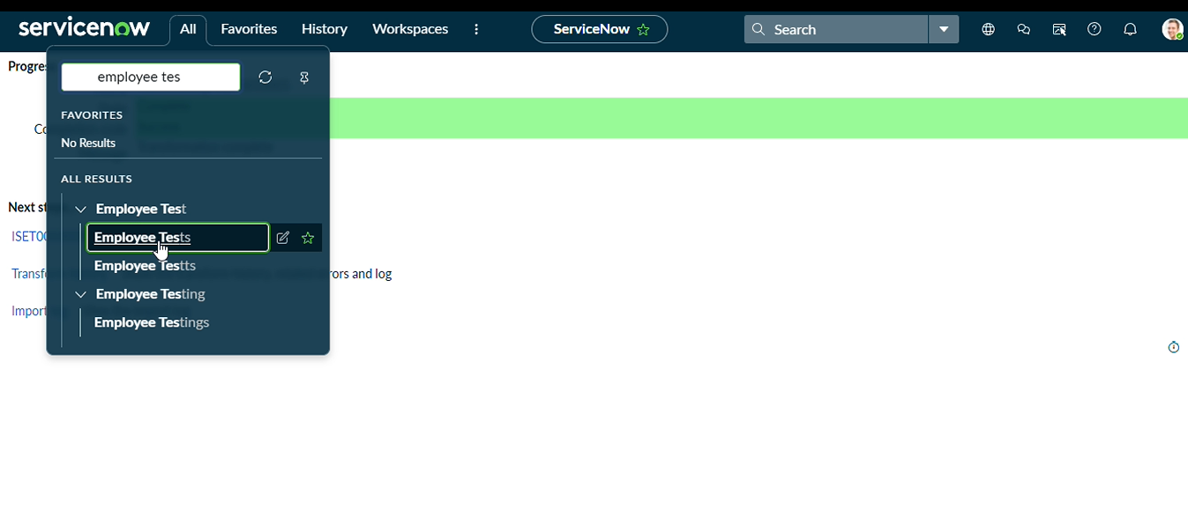
2.As our import got succeeded, all the records are created in the Employee Test Table.

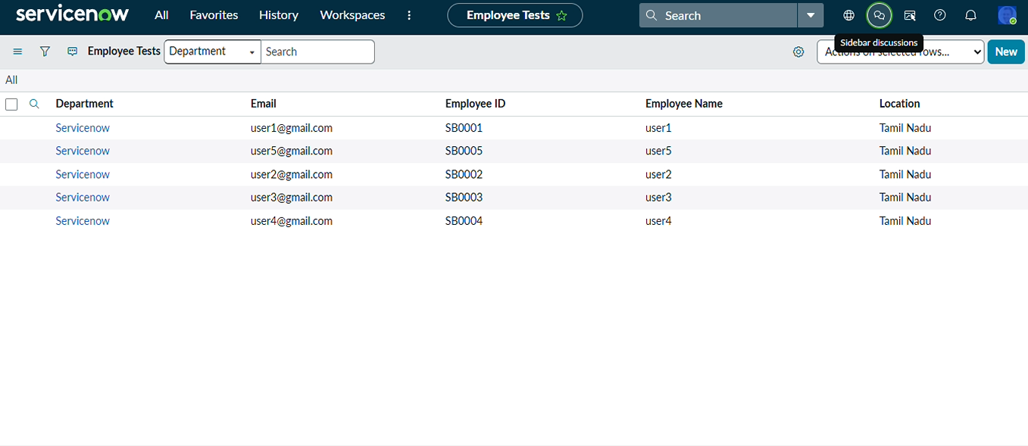
3.Make sure you rearrange the fields accordingly by using Personalised List Columns

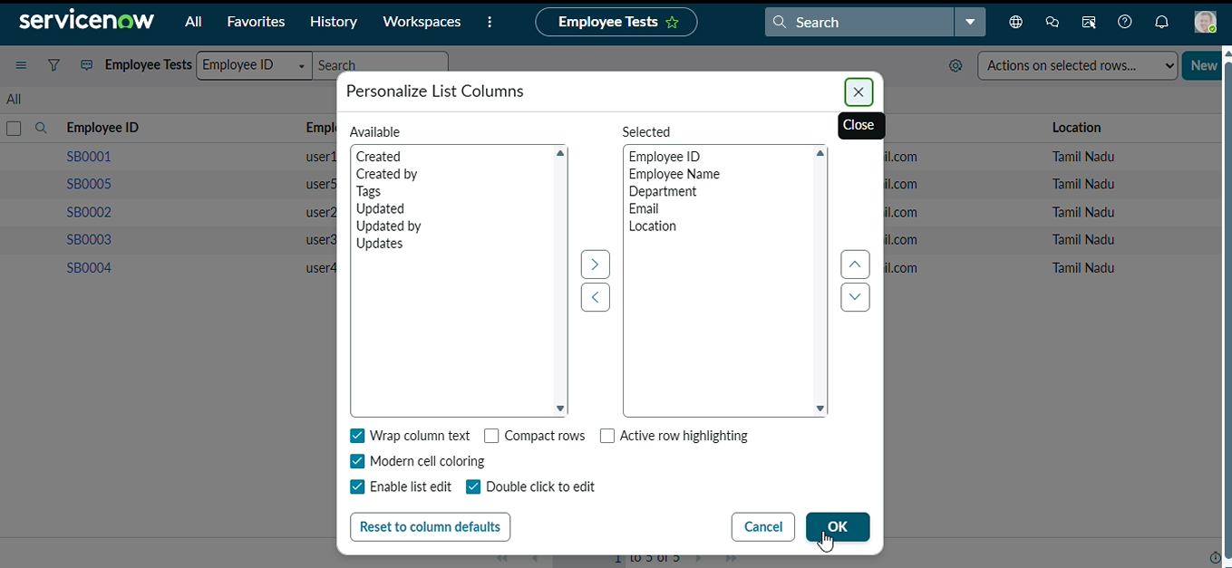
4.Click on OK
Final Result:
All the records are successfully imported into the ServiceNow system with Import Set, Transform Map.

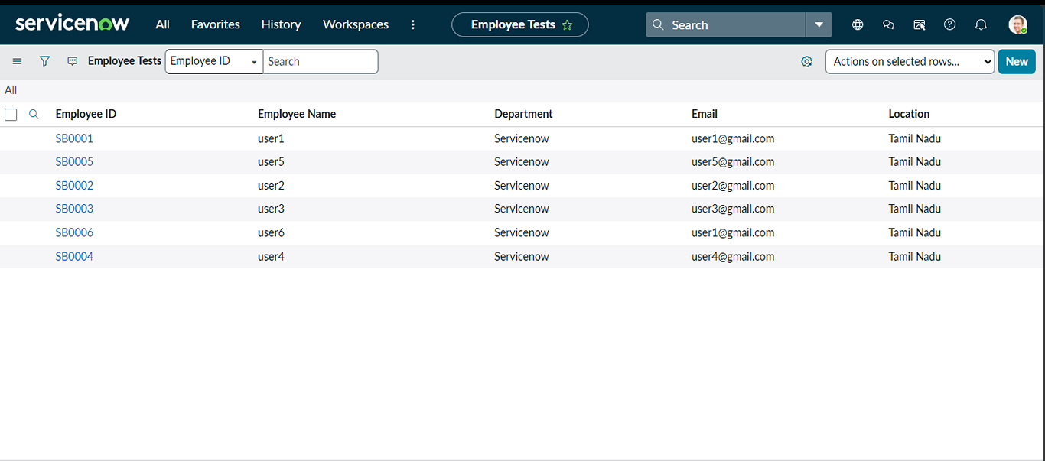
Activity 6 : Enable Coalesce to Avoid Duplicate Records
In real projects, the same employee data may be imported multiple times.To prevent duplicate employee records, we use Coalesce. The Coalesce will update the same records with new values if we add and the duplicate values are not inserted.
Steps:
1.Open Transform map Under System import sets On All menus.
2.Open the Created Transform map , Name is Sample Spreadsheet Import.
3.Under Related list, select the Field maps Section and Make any one field Coalesce True which appears in False.
4.Now save the form.
5.Then again add some data which is in Excel format.

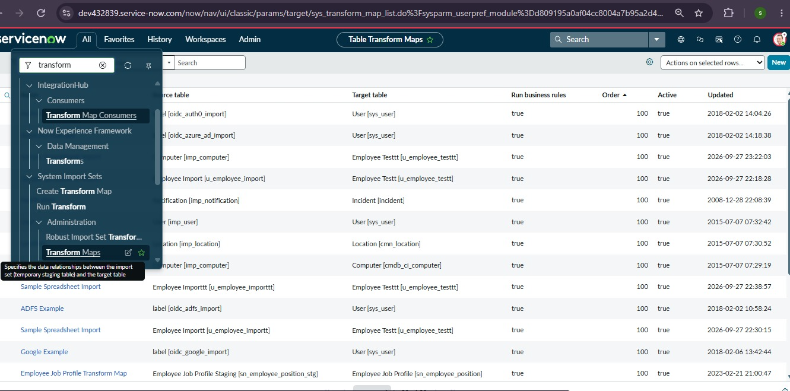
6.Open Transform map Which You are Created
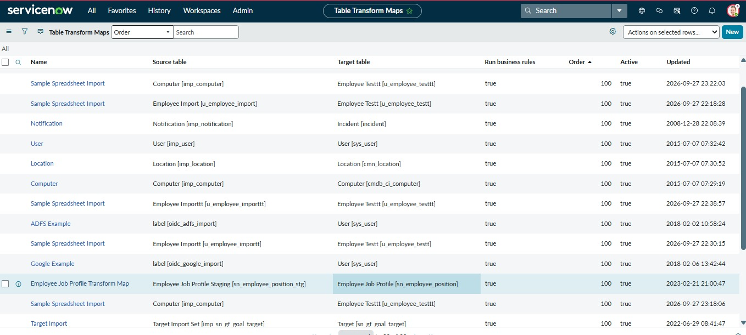
7.Go to field mapping

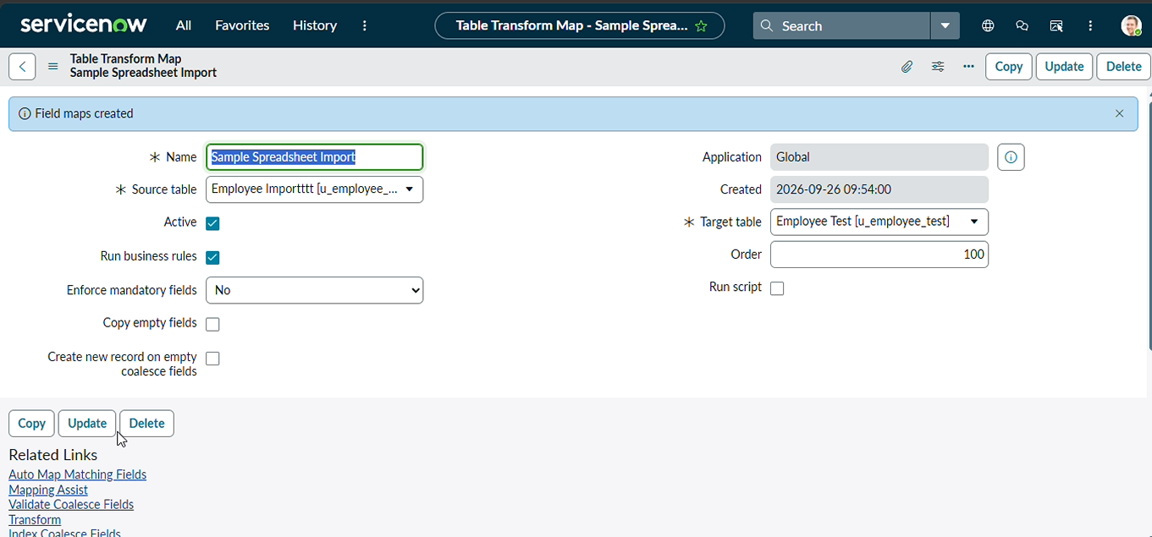
8.Go to coalesce field make true for one unique field

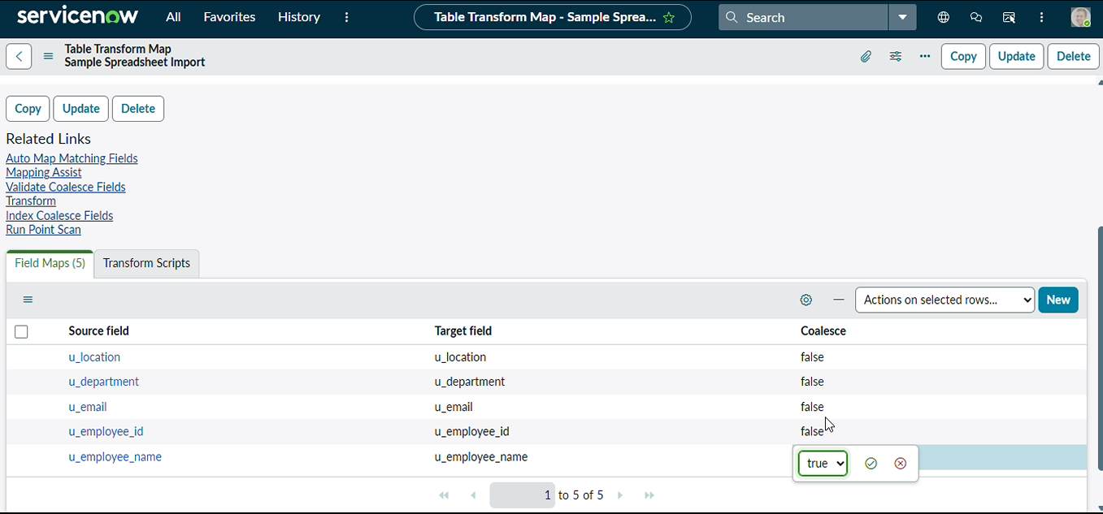
Activity 7 : Inserting New Data In Excel Format
Steps :
1.Navigate to All menus.
2.Search for Load data Under System Import set Open Load Data.
3.Fill the details as
4.Import set table as select Existing table {Employee Import}.
5.Source of Import is Select File and choose the file from Files.
6.Sheet number : 1, Header row : 1.
7.Now Click submit.

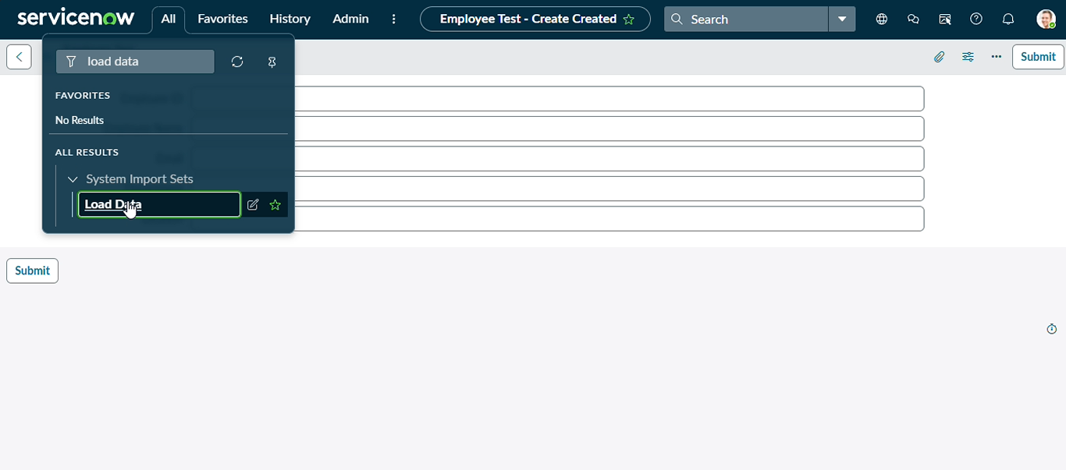

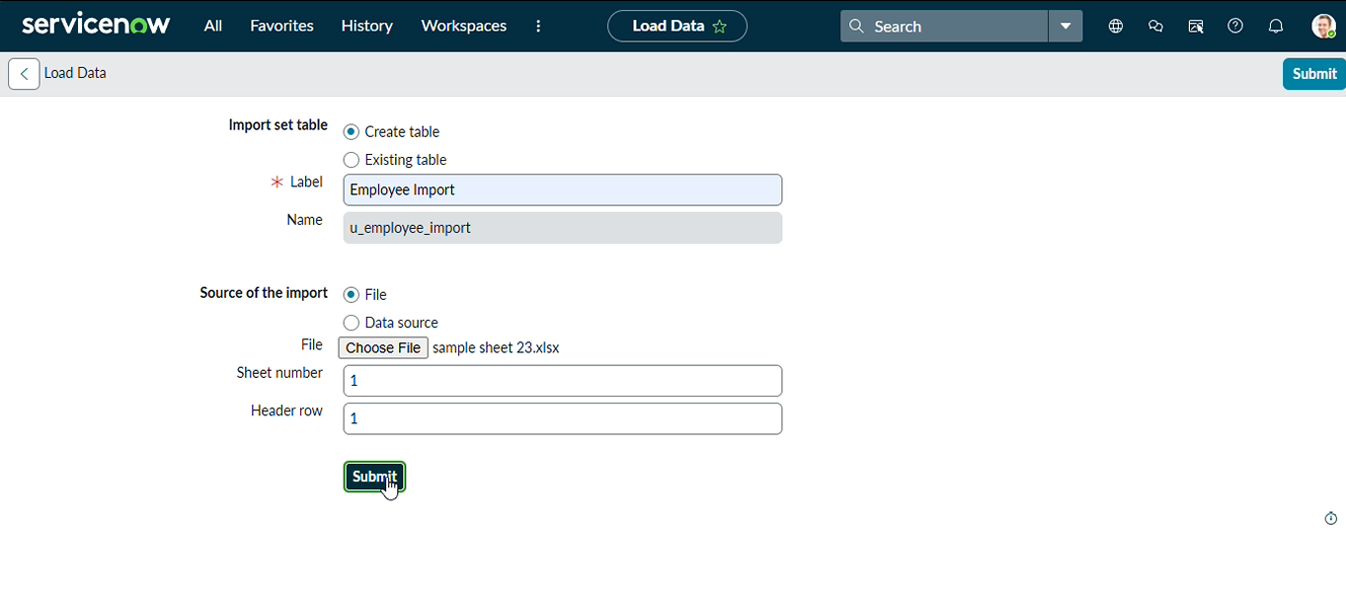
8.Newly Created Excel Data is this.

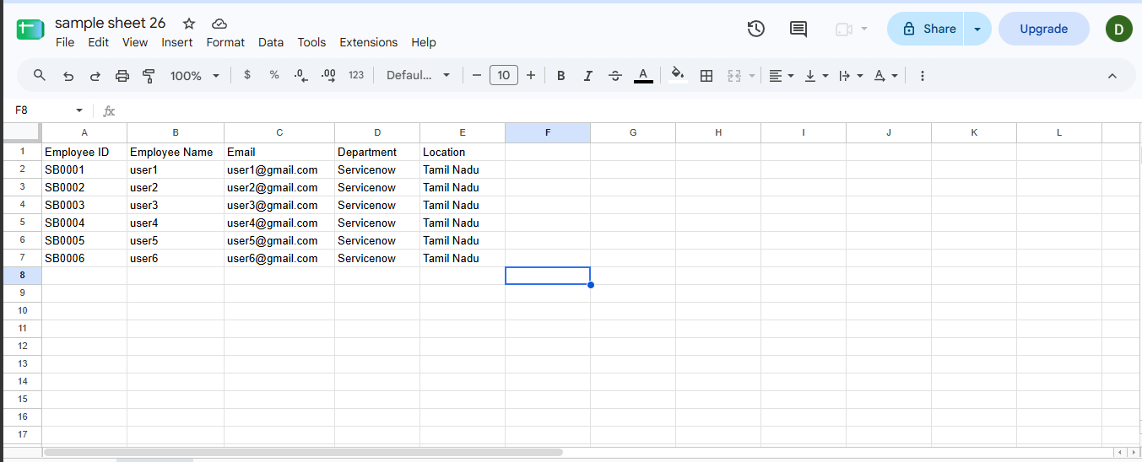
9.It is the previously added data.
10.Now, In this new data we added 4 rows of the 2 rows with the same existing data with different Name changed and Email changed.
11.That Raviteja Employee Email was Changed to
[test10@gmail.com → test18@gmail.com ].
12.And Employee ID with SB-OOO4 name was changed to
[Ajay kumar → Ajay].
13.And two other new Employee ID’s are added.
14.Now after submitting the form it appears as State Completed and Success.

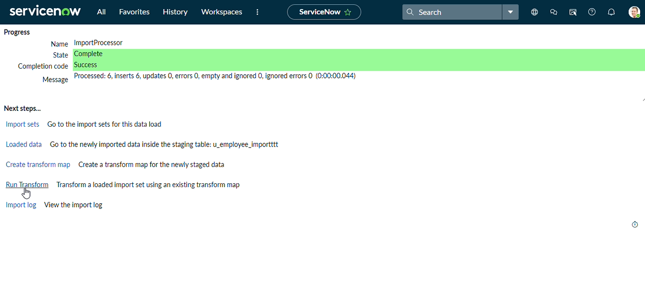

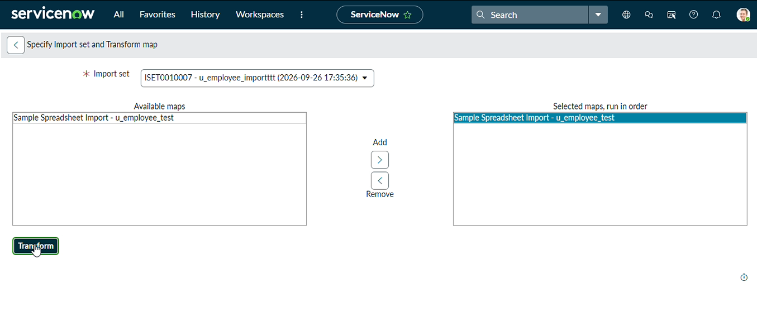

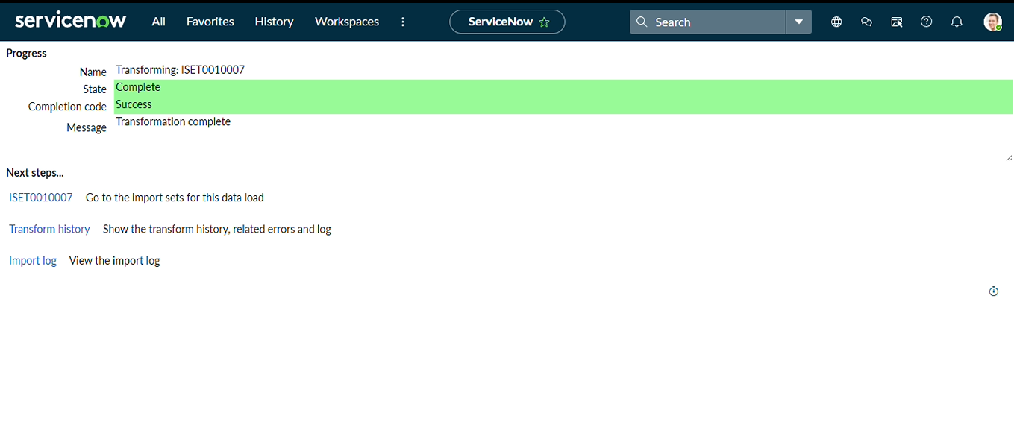
17.Now the State is completed and Success.
18.Now again click on the Transform history then it shows the newly added data and its status of Inserted and Skipped values out the given data.
19.From the above figure : total 4 rows are uploaded out of 2 are Inserted that are two new ID’s.
20.And 2 rows are updates that are Same ID’s with different Name and different Email that we changed.
21.Then Open the Employee Tests table and see the rows updated and inserted.

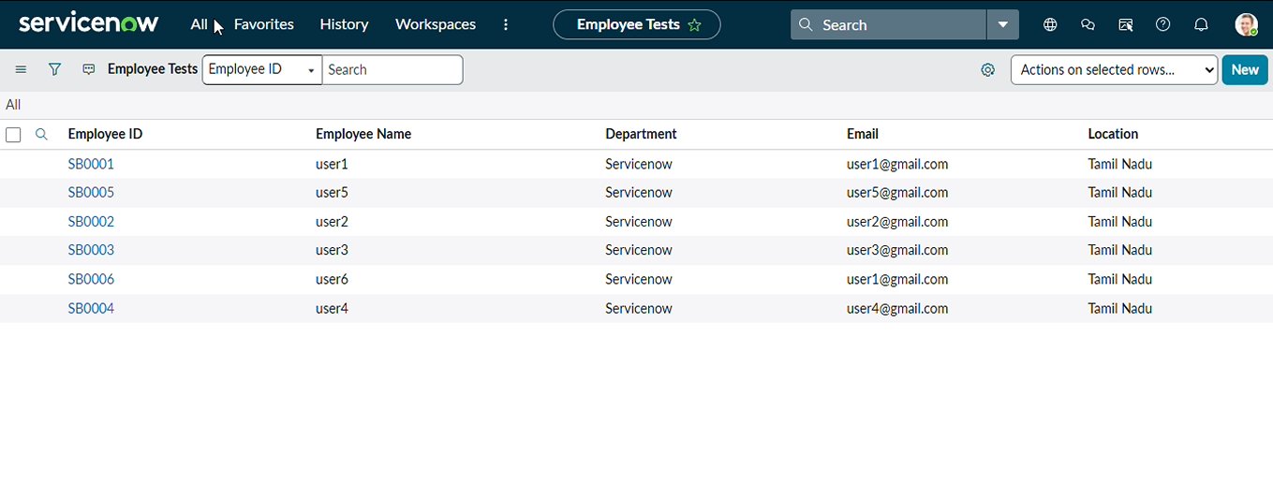
22.Inserted with the same data.
23.Then Open the Transform history to check
24.Here we can see the total 4 are uploaded.
25.On that 0 rows are Inserted and updates 0 and Ignored 4 rows.
26.That same sheet we uploaded to the same transform map we created.

